Login to remote Linux server
ssh username@serverip
Example for server with ip 159.65.222.96 and user as root
ssh root@159.65.222.96
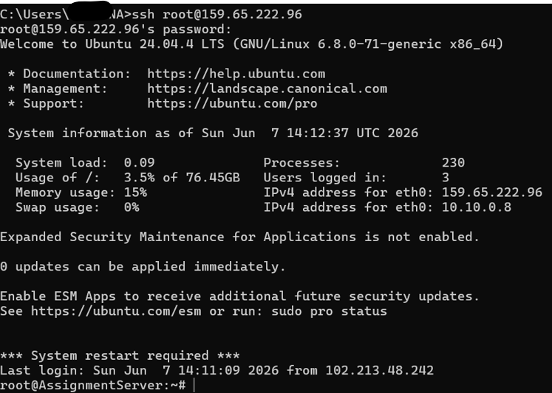

Files and Directories
List directories
ls
List directories showing the long format and data about the files like date,size and owner
ls -l
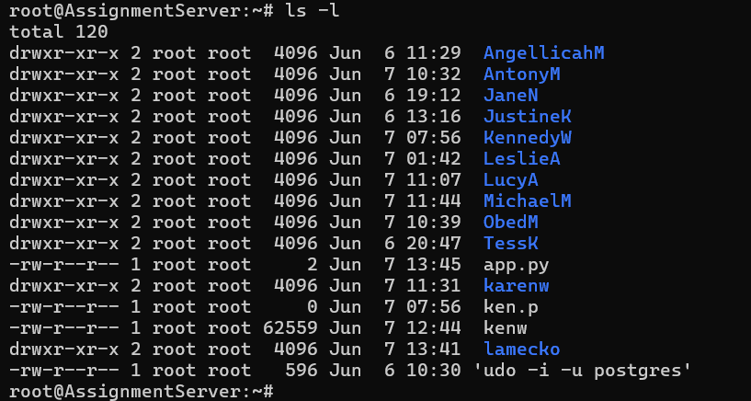

Create directories
mkdir directoryname
for example make a directory named bkassignment
mkdir bkassignment
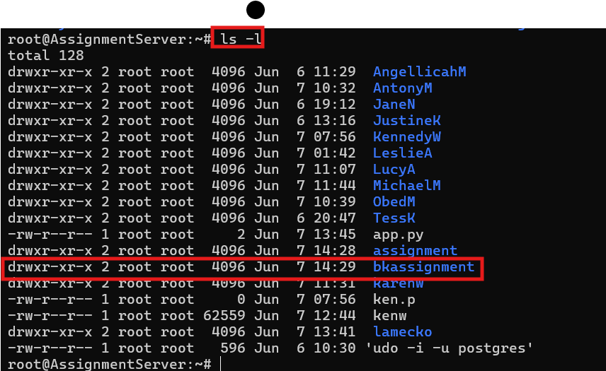

Navigate Directories
cd directoryname
For example to move to bkassignment directory
cd bkassignment

Files Management
Create files using nano or vim editor
nano
nano filename
For example create .txt file with the name usingvim
nano usingnano.txt
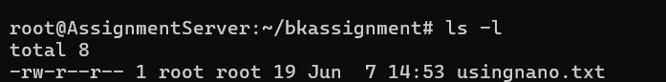

vim
vim filename
For example create .txt file with the name usingvim
vim usingvim.txt

View file contents
cat filename
For example view file name as usingvim.txt
cat usingvim.txt

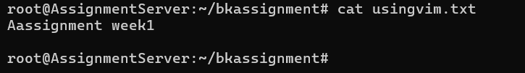

Delete files
rm filename
For example delete file name usingvim.txt
rm usingvim.txt
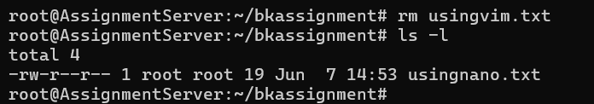

Delete with confirm before delete(interactive)
rm -i filename
For example delete file name usingvim.txt
rm usingvim.txt

Rename files
mv oldfile newfile
For example rename usingvim.txt to usingvimupdated.txt
mv usingvim.txt usingvimupdated.txt

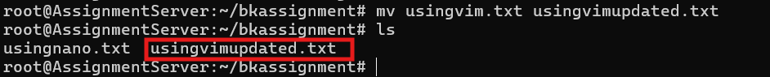

Copy files
cp sourcefile destinationfile
For example create a copy of usingvimupdated.txt and name it usingvimcopy.txt
cp usingvimupdated.txt usingvimcopy.txt

Before
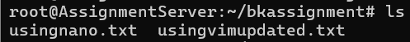
After

# Networking
# 13 View Network interfaces
>ifconfig

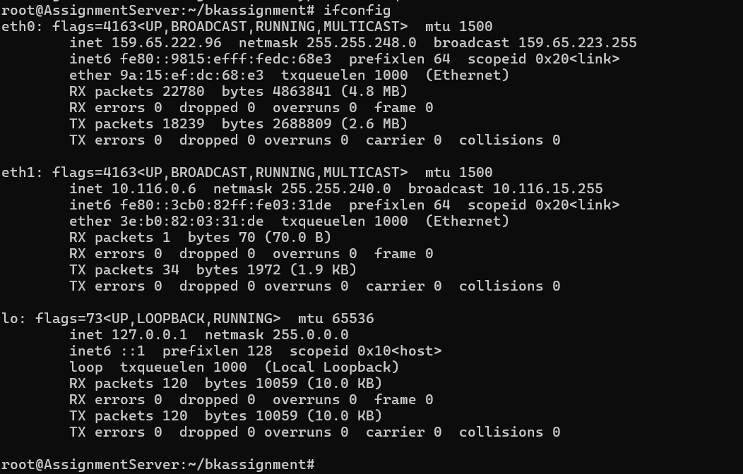

# 14 Check end point reachability
>ping endpoint ip
For example testing youtube.com reachability
>ping youtube.com

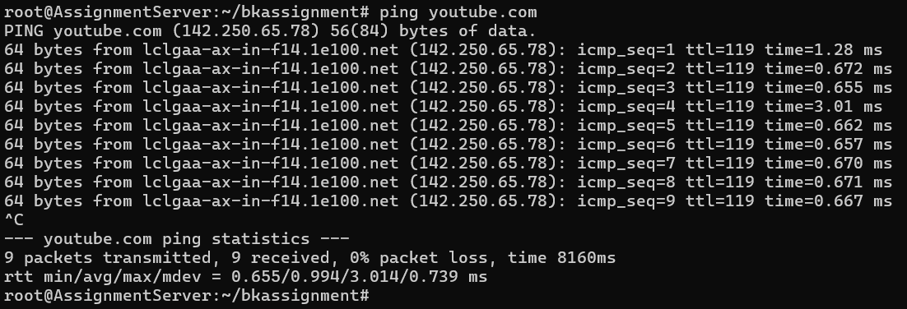
# 15 Downloadfiles from internet
>wget fileaddress
For example downloading file from https://ash-speed.hetzner.com/
>wget https://ash-speed.hetzner.com/

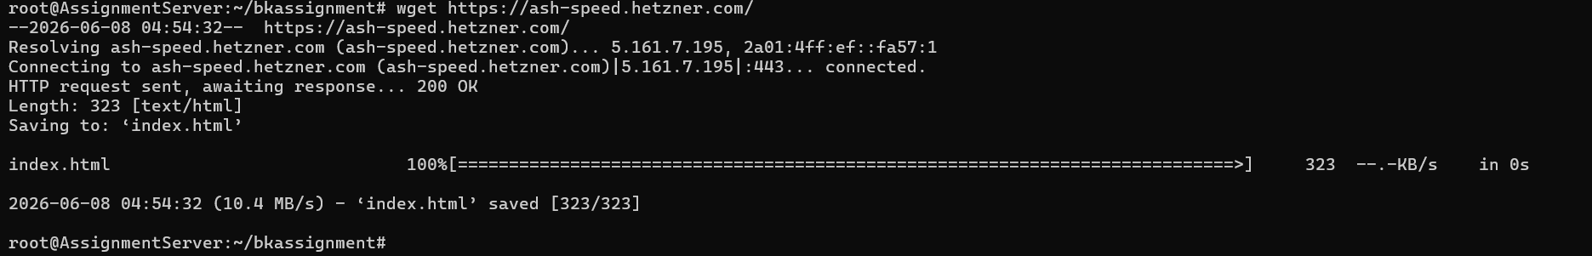

Add users
user add
For example adding user name benardm
>useradd benardm
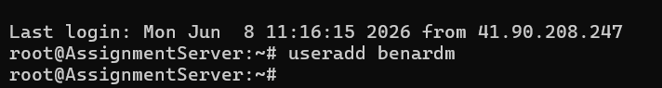

# 17 Add users and home directory
>sudo useradd -m username
For example add user with name benardk
>sudo useradd -m benardk

# 19 Change user
su – username
For example switching from root to benardk
su – benardk

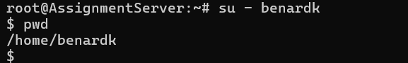

# 18 View users
>cat /etc/passwd
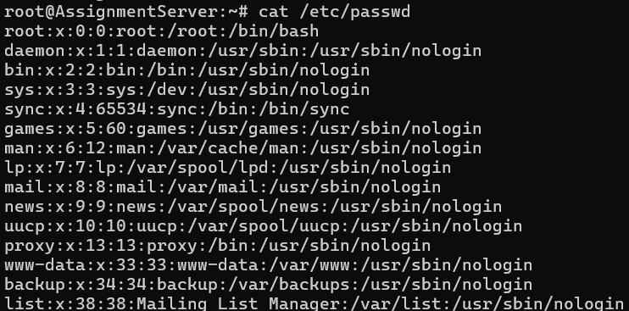

#20 check current user
>whoami
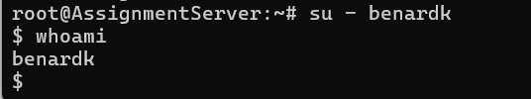

# 20 Check running process
>top
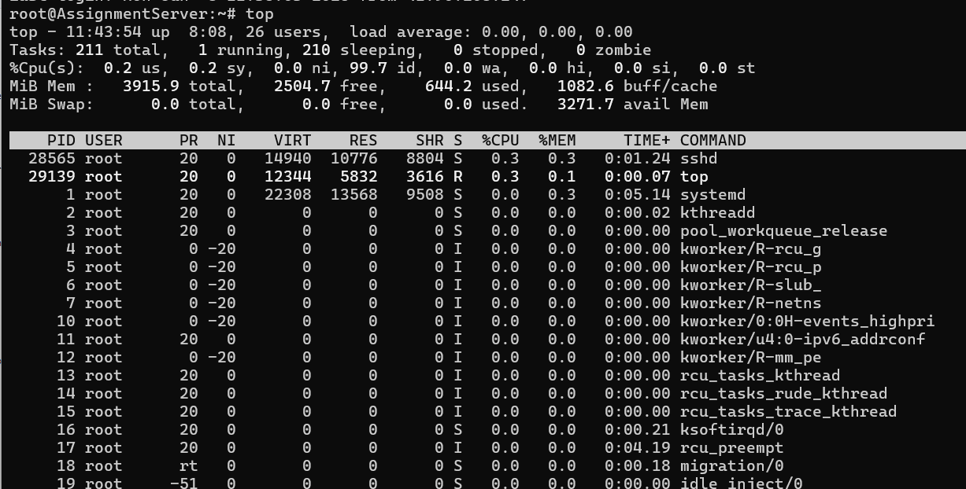

#21 Check memory utilisation
>free

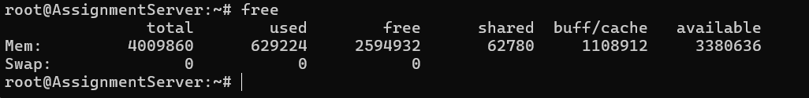

#22 Secure copy from local pc to remote server
>scp filename username@ip:target directory
For example
scp Linux-Basic-Commands.txt root@159.65.222.96:/home/benardk/securecopy

#23 Secure copy from remote server to local PC
scp username@remoteip:target directory/filename .
For example
scp root@159.65.222.96:/home/benardk/securecopy/remote.txt .
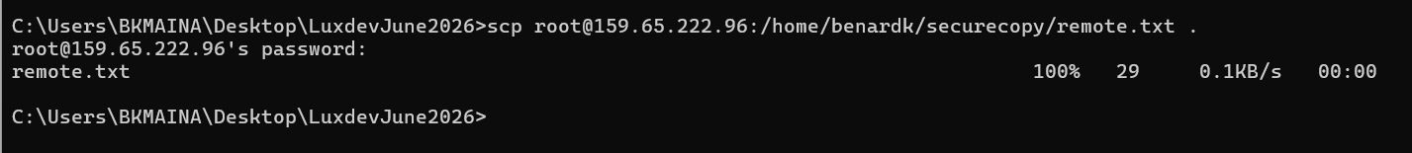

#23 Secure copy from remote server to local PC
scp username@remoteip:target directory/filename .
For example
scp root@159.65.222.96:/home/benardk/securecopy/remote.txt .
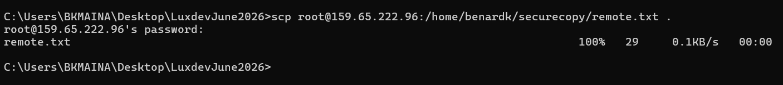

#24 Check currently logged users
>who

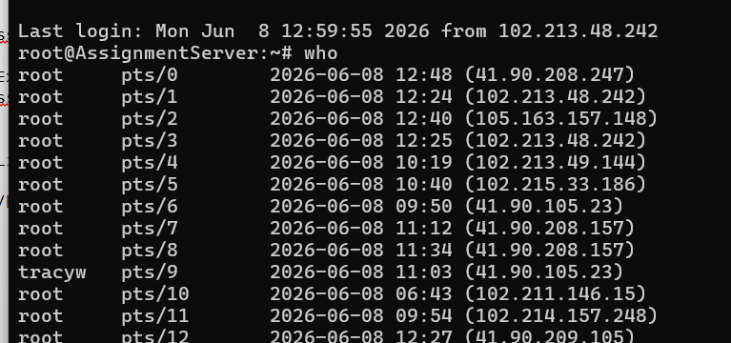

# 25 Check disk space
>df
>df -h shows human readable details
